

The layouts Need lots of cosmetic work.

All images are in the Media library (my boards)

Collection: Categories_all. Images were manually attached to image fields.

Dynamic Page: Categories_all (List): This page looks good. But the buttons are not connected. Should link to Products_all (Item=selection):

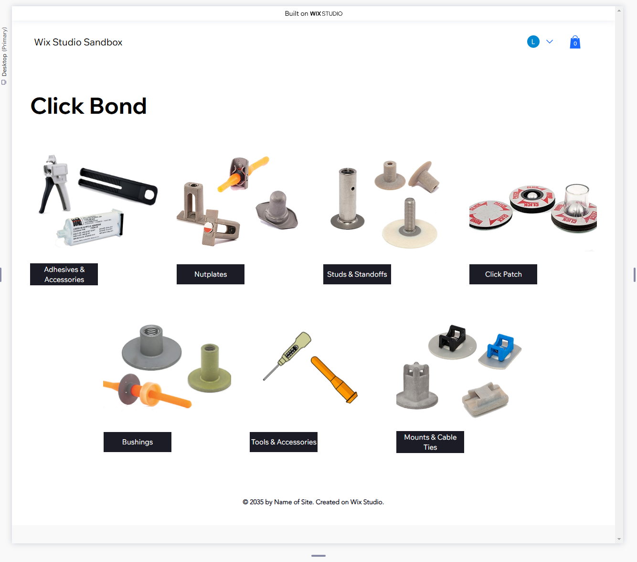

All images are in the Media library (my boards)

Collection: Products_all. Images need to be “linked” to Image field.

Dynamic Page: Products_all (Item): This page looks OK. Needs the images to be connected in the Products collection.

But the buttons are not connected. Should link to Parts_all (Item=selection):

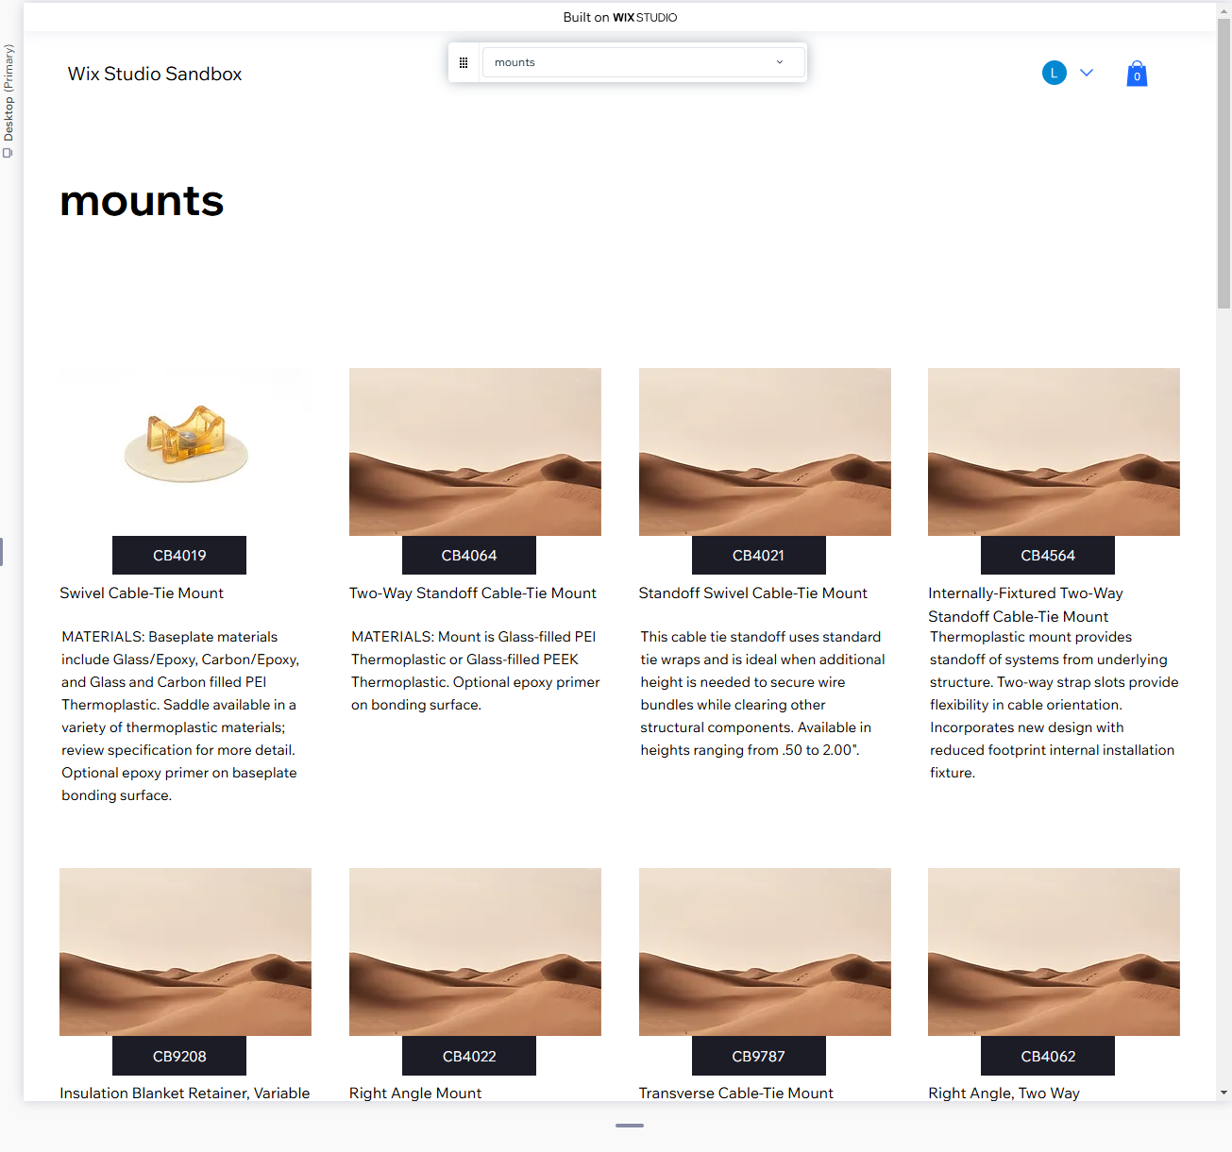

Collections: Products_all. In header.

Collections: Parts_all. In repeater.

Need to link/synchronize header & repeater

Dynamic Page: Parts_all (Item): This page layout is not right:

“Specification” Button need to open a PDF that is located in the media area (my boards)

Needs Quantity in each repeater cell

Needs Text input in repeater cell (only for some part numbers. I can create a flag in the collection)

Add to cart button needs code

Enter Part number to quote

